**NALAIYA THIRAN**

**WEEK 2 REPORT**

**Phase 2 Description:** Ideation Phase (Literature Survey, Empathize, Defining Problem Statement, Ideation)

2.1 Literature survey on the selected project & Information Gathering

Collected the relevant information on project use-case, referred the existing solutions, technical papers, research publications etc.

Paper 1 - **IoT Based Smart Gadget for Child Safety and Tracking**

Publisher: International Journal of Research in Engineering, Science and Management (IJRESM)

Reference - <https://www.ijresm.com/Vol.3_2020/Vol3_Iss6_June20/IJRESM_V3_I6_79.pdf>

Paper 2 - **Child Safety Monitoring System Based on IoT**

Publisher: International Conference on Physics and Photonics Processes in Nano Sciences (IOP)

Reference - <https://iopscience.iop.org/article/10.1088/1742-6596/1362/1/012012/pdf>

Paper 3 - **A Research on Child Safety Wearable devices**

Publisher: International Journal of Scientific Development and Research (IJSDR)

Reference - <https://www.ijsdr.org/papers/IJSDR1810024.pdf>

2.2 Attended the technology trainings as per the training calendar

**IoT - B4 - 4M6E (Morning Session) - Day 1 (01.09.2022)**

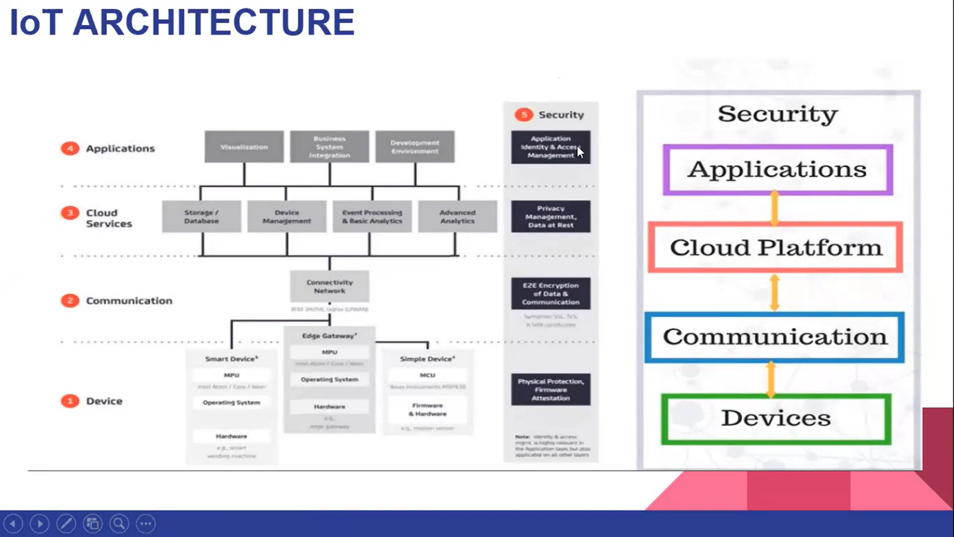

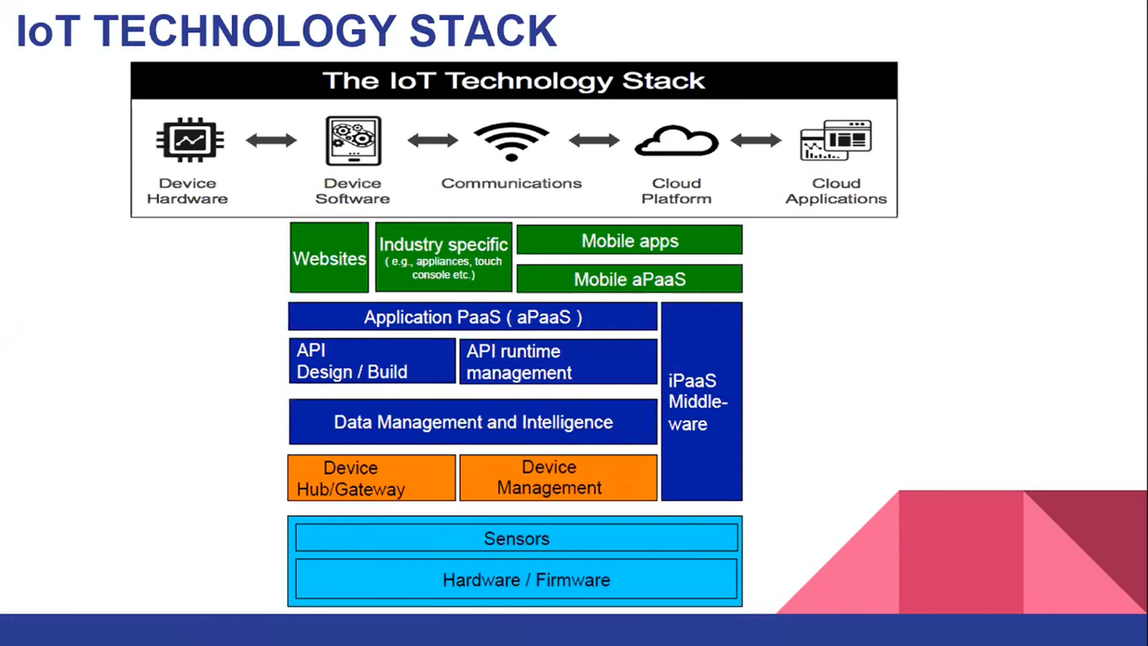

**IoT-B4-4M6E (Evening Session)-Day-2 (03.09.2022)**

